**FOOD ORDERING SYSTEM UML DIAGRAMS**

**S.JAHNAVI**

**(192011242)**

**1.USE CASE DIAGRAM**

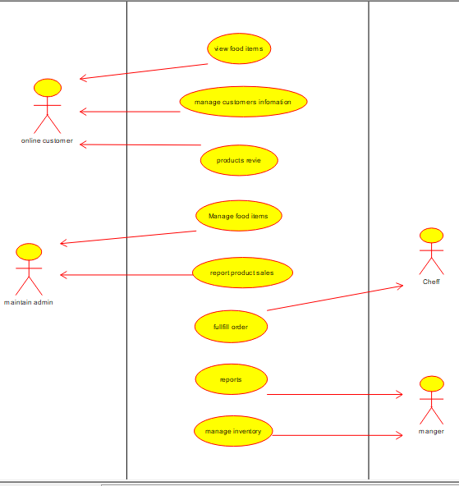

**2.SEQUENCE DIAGRAM**

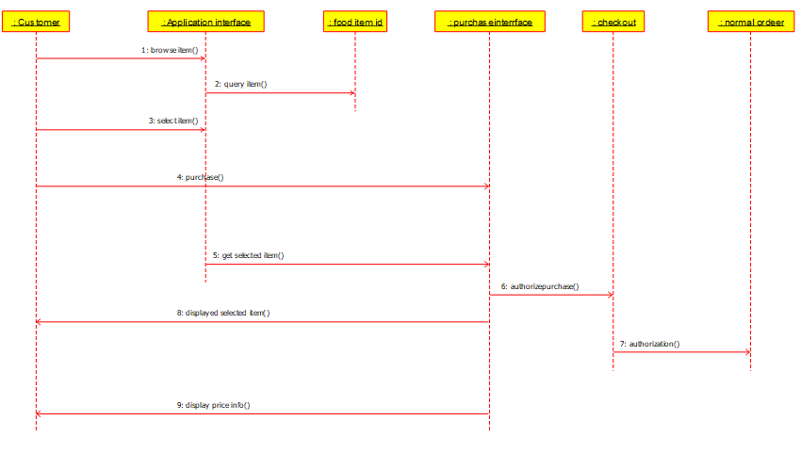

**3.CLASS DIAGRAM**

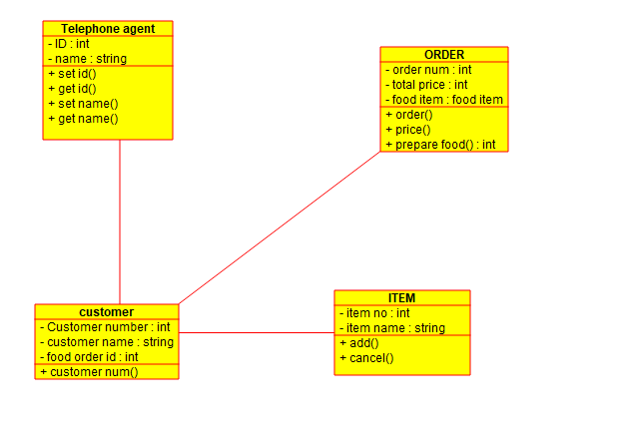

**4.STATE DIAGRAM / ACTIVITY DIAGRAM**

